REPORT OUTLINE

PART I – Team Information

The members of Team 4 (‘Please Compile’) are: Luke Grammer, Seungjin Kim, and Daniel Hain-Trevino.

Luke Grammer implemented the Window_manager, Main_window, Hint, and Help_window classes, as well as Main.cpp.

Seungjin Kim implemented the Game, Game_window, Tile, and User_score classes.

Daniel Hain-Trevino implemented the Difficulty_window, Initials_window, and Game_over_window classes, and also one extra item (multiple randomly selected tilesets for each difficulty level)

Each team member did a fair share of work for this project.

PART II – The Problem

The problem was to create a functional 15 puzzle game using the FLTK graphics library in C++, being sure to implement a main menu, four different difficulty settings, a top 5 scores system using user-entered initials, and a hint button. The difficulty should determine how many moves the player receives, as well as the initial board layout. The score should be calculated as the number of moves taken multiplied by the tiles in their correct position. The hint functionality should use the Manhattan distance formula for each of the possible moves, and tell the player the move resulting in the smallest distance. The moves remaining as well as the number of incorrect tiles should be displayed to the screen during the game, and update accordingly. The top 5 scores should be displayed during the game, as well as written to a file for retrieval in subsequent games. A game over menu should display after all moves have been made, asking if the user wants to play another game or quit.

PART III – Restrictions and Limitations

The program needed to be written in C++, and implement FLTK graphics. Each function must fit inside of a standard console window (24 lines). The program must use at least two different features of C++11, C++14, or C++17. Each team member must write at least two classes. All input and output for the program must be through a GUI. The scores must be saved to a file and kept for use in subsequent runs of the program.

PART IV – Explanation of Approach

Each different screen (main menu, help, difficulty, initials, game, game over) is displayed through its own window, which displays on top of the previous window, and the previous window is then destroyed. In order to display different windows, a window manager was implemented in order to display and destroy windows as needed. The game itself is displayed through the Game_window class, and a Game object is passed to it to supply the difficulty, number of moves given to the user, top scores for each difficulty, and some initial game starting conditions. The Game_window manages information from there, updating the window with each move and implementing the core logic of the game. A score object and tile object were created to simplify reading/writing scores and implementing tile logic.

PART V – Sample run (screenshots)

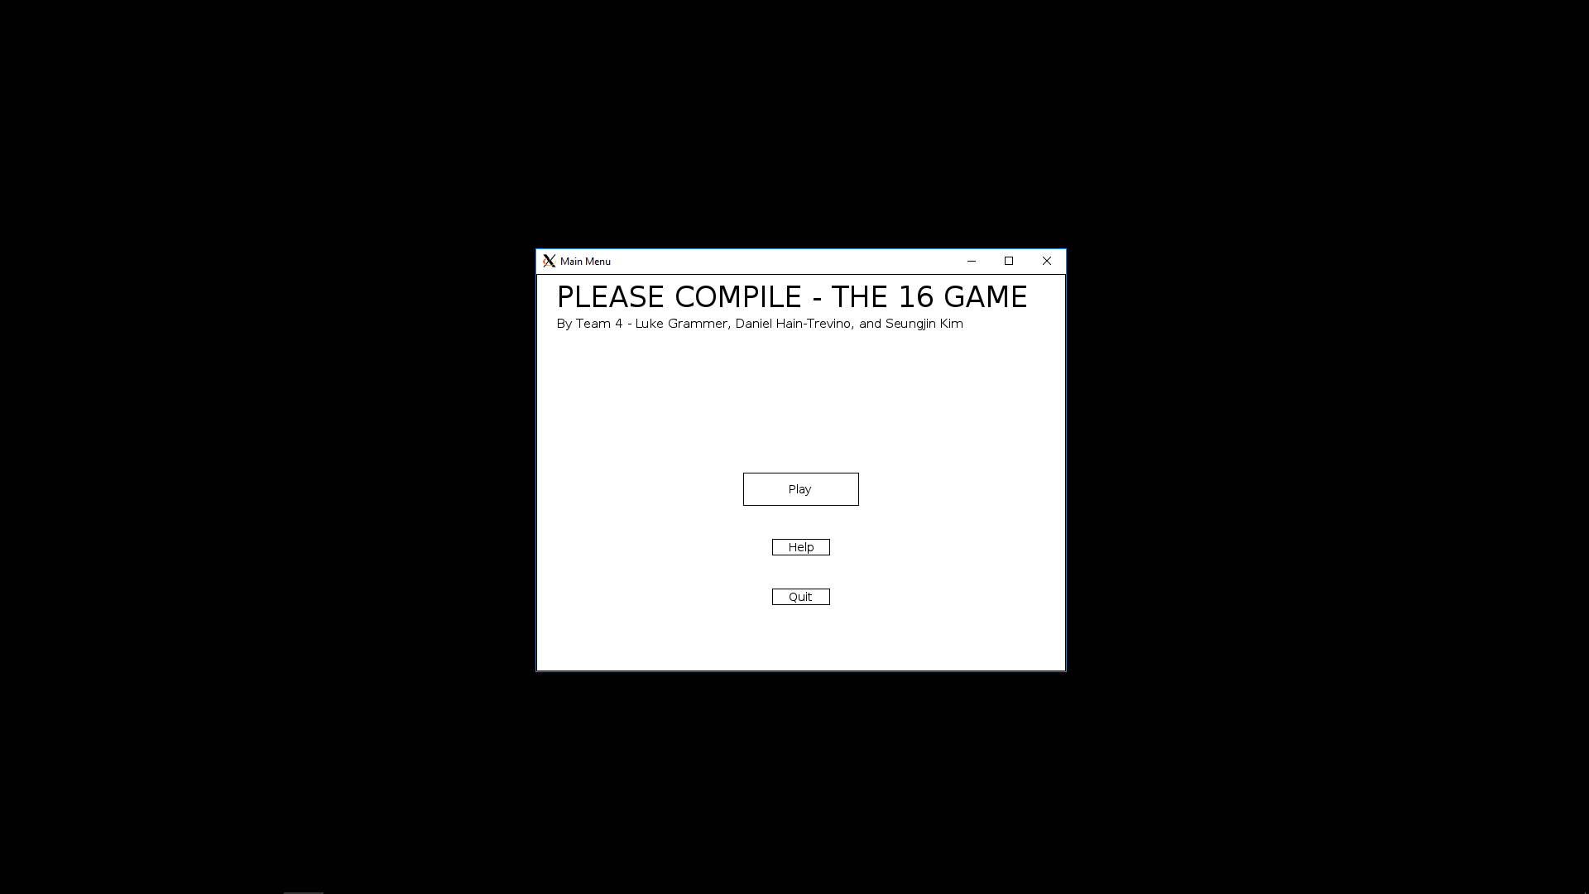

Main menu

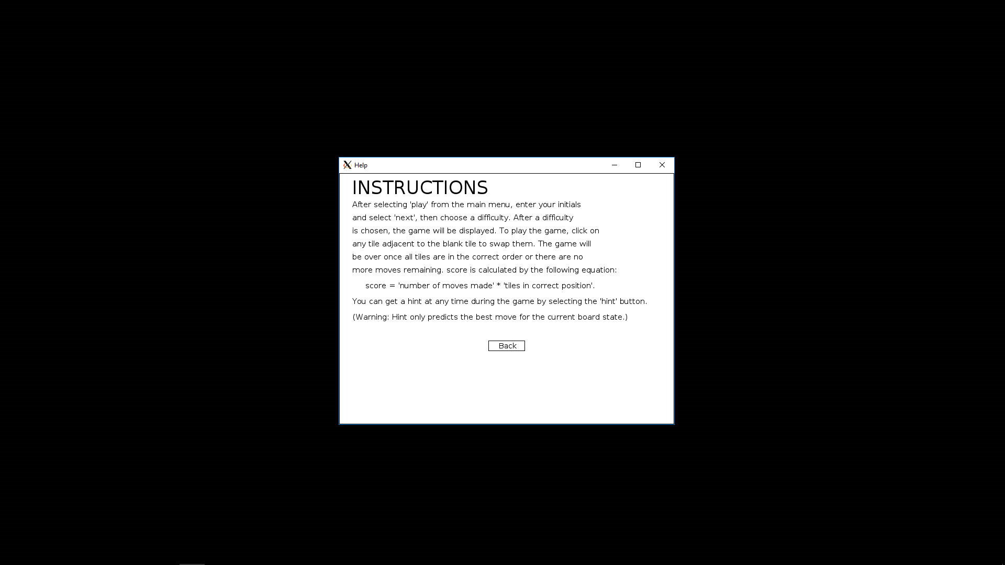

Instructions screen

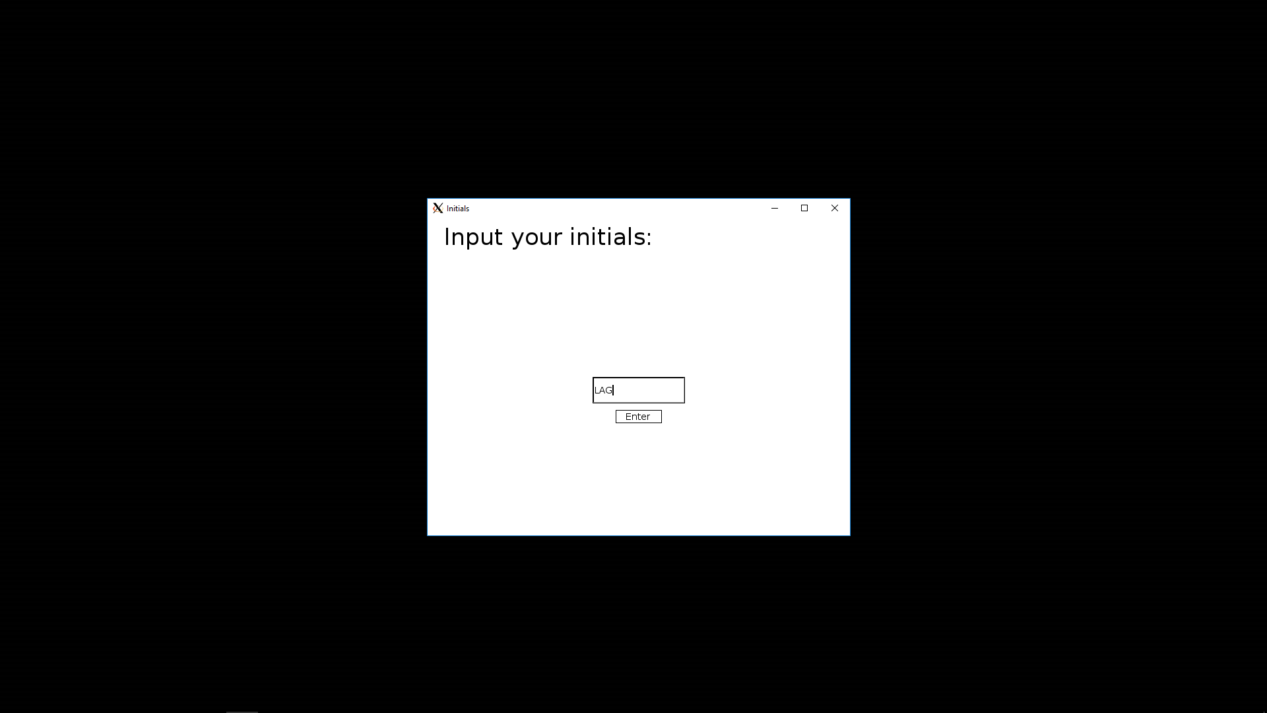

Initials screen

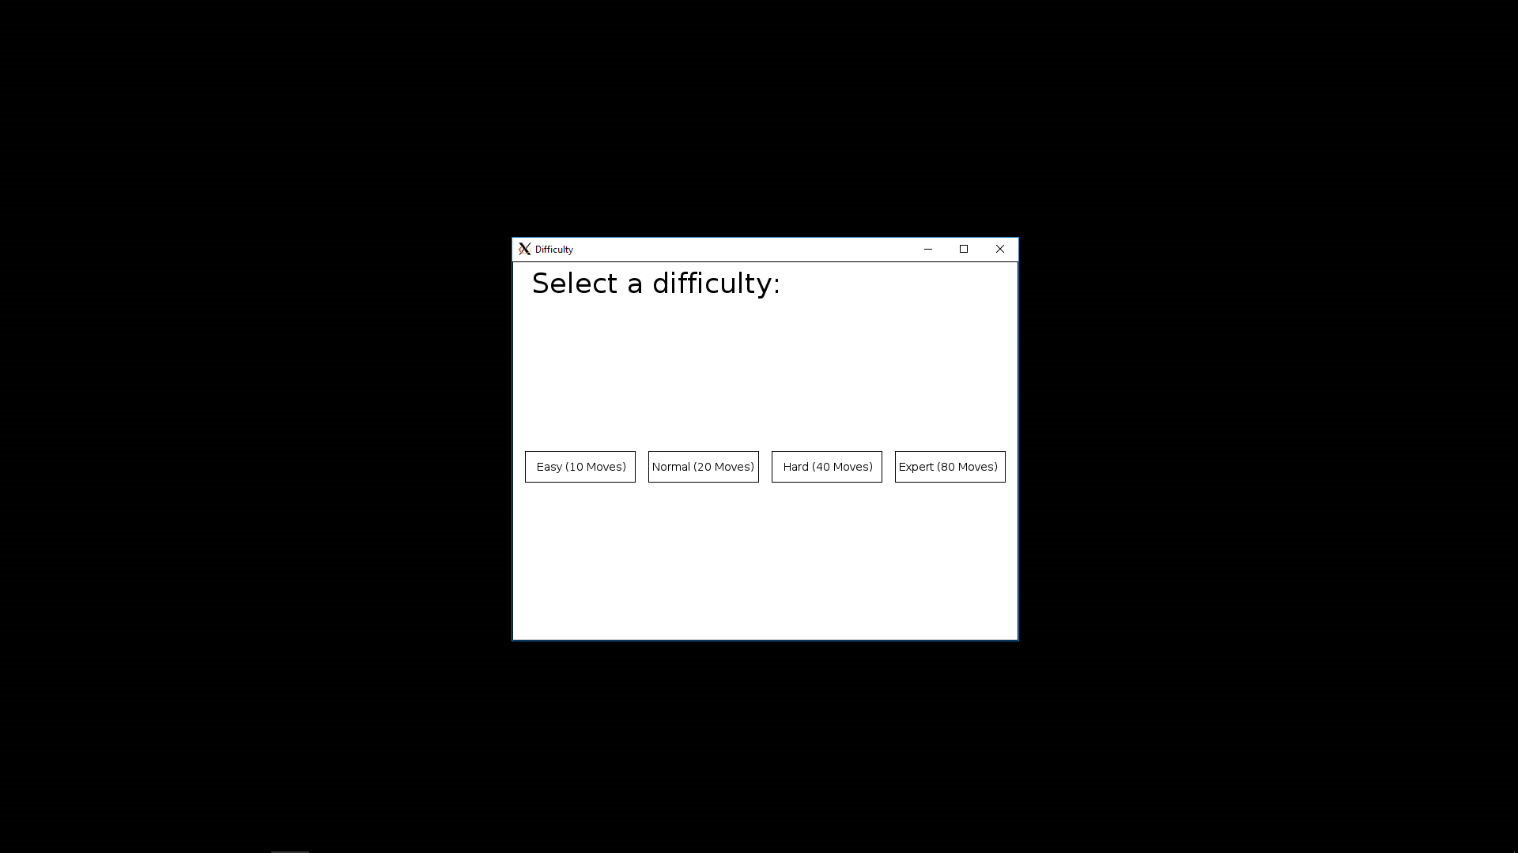

Difficulty screen

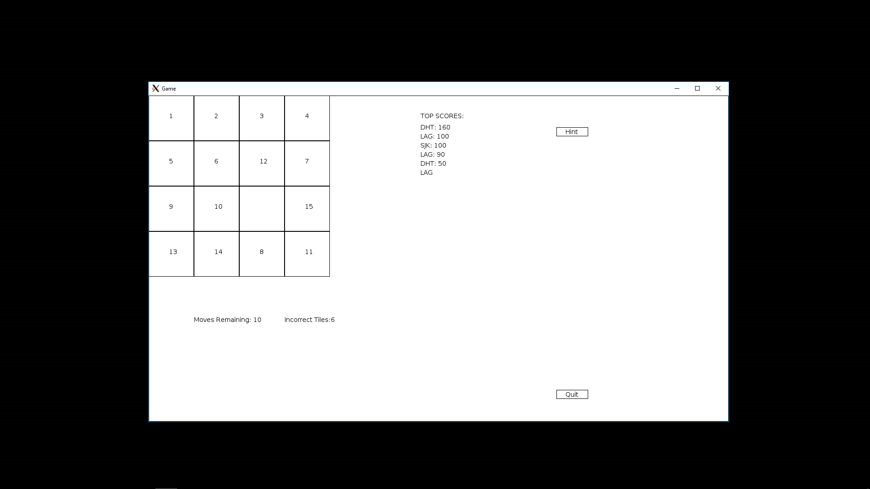

Game window

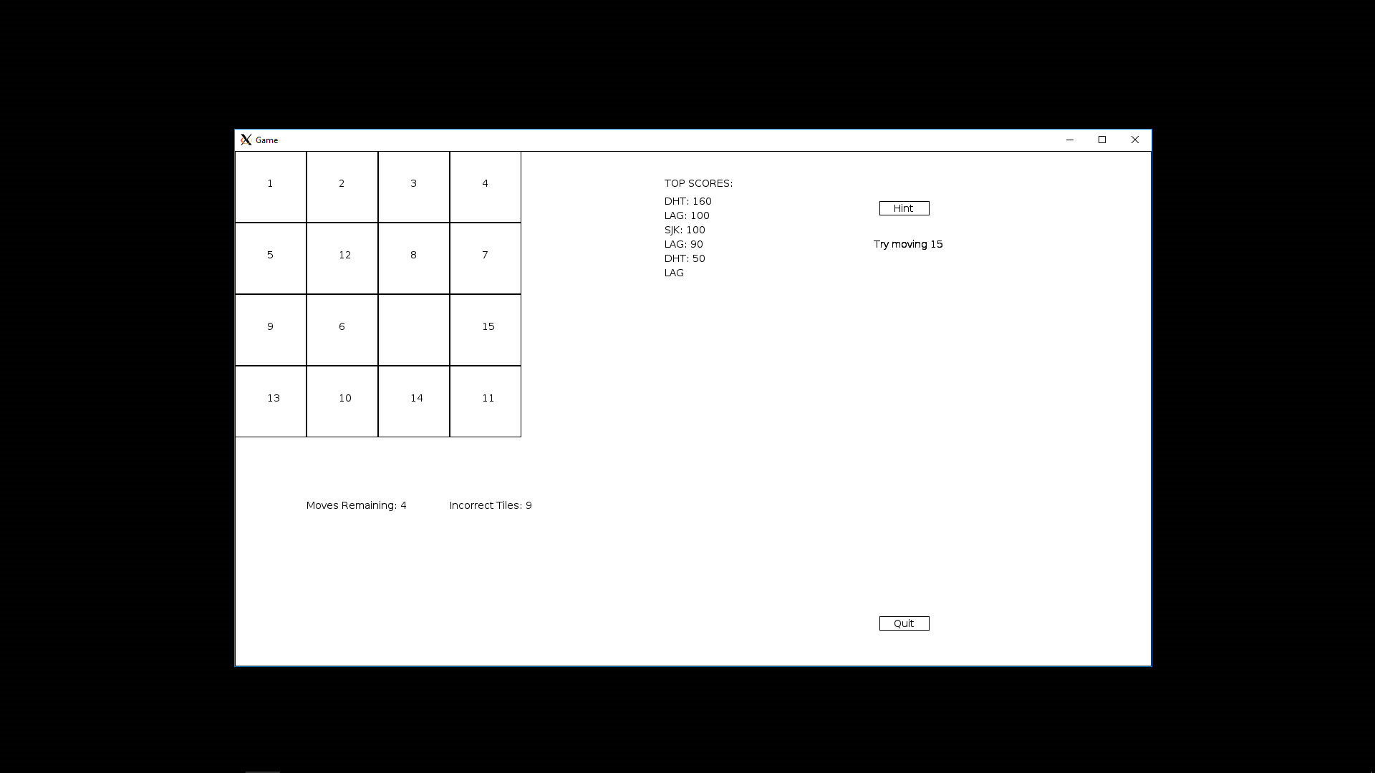

Game window with hint displayed

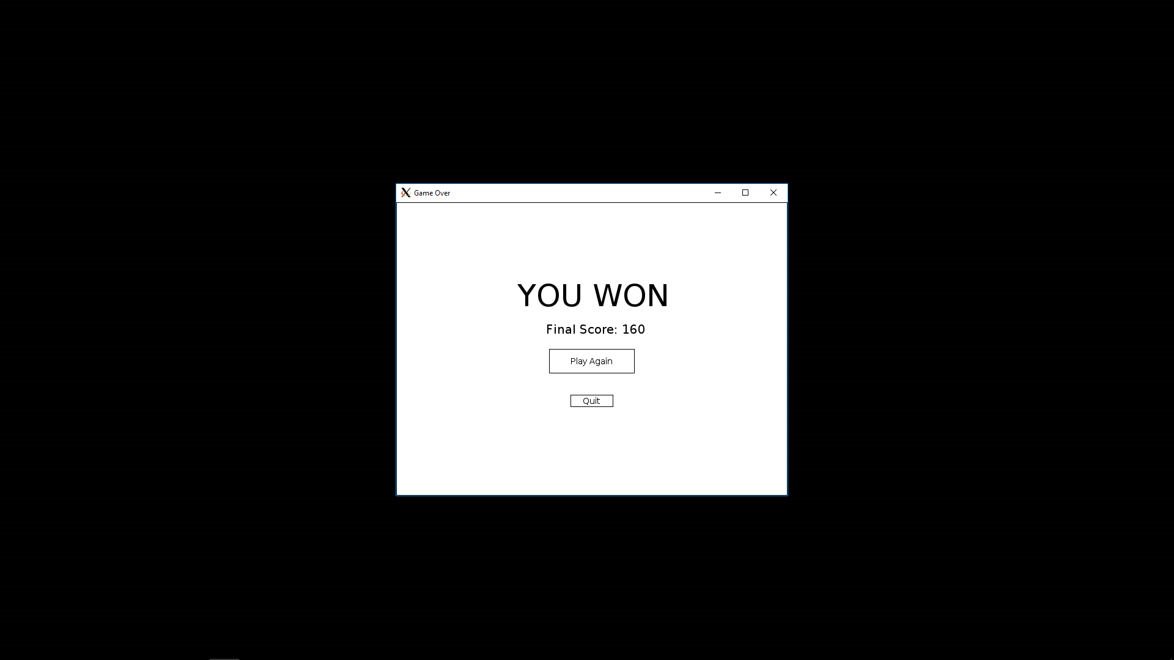

Game over (win)

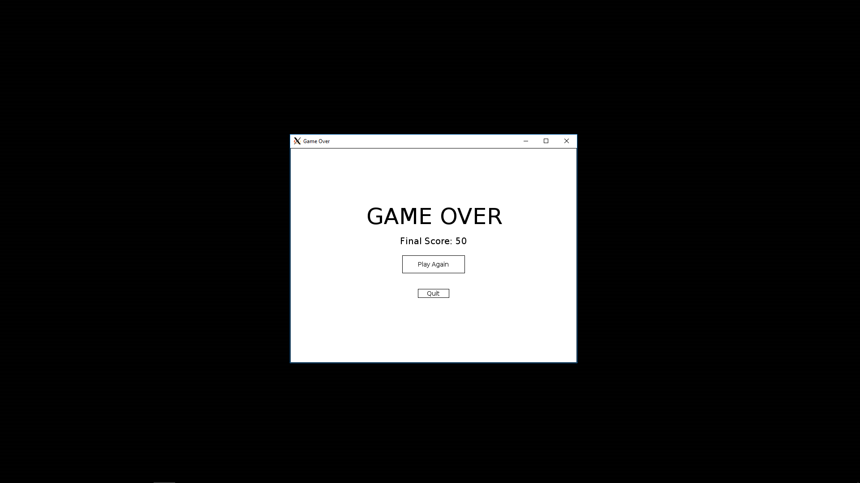

Game over (lose)

PART VI – Results and Analysis

The game conforms to each specification, and runs more or less as expected without any known bugs which have not been fixed. The hint functionality is sub-optimal since it only recommends the best move for each particular board layout, that is to say, it doesn’t look ahead to see which move is best overall. This can lead to infinite loops where the hint button tells you to move some tile, and if you follow its recommendation and ask for another hint, it may tell you to move it back. This result is its expected behavior, however, using the Manhattan distance formula provided by the project specifications.

PART VII – Conclusions (what did you show/learn)

Learning some of the intricacies of the FLTK Graphics library, as well as the classes defined by Stroustrup, were almost essential to completing the project. We learned more about scope, user defined data types (classes and structs), and we have also gained some practical experience programming applications with a GUI. This kind of programming is different in many ways compared to console applications, and required a bit of getting used to. We were also able to practice coordinating and communicating with other group members, which was a fundamental part of the project.

PART VIII – Future Research (how it could be improved)

The game could be improved in several ways. One such way would be to design a more complex hint generator which would be able to look ahead several moves. Another way would be to redesign the window manager system to display all the different screens on one single window. Sliding tile animations could be added, or various sound effects/background music. While a minimalistic graphical style was chosen in order to meet the 24 line function requirement, graphical objects could be added relatively easily to make the game more graphically impressive, such as adding images for textures or closed polylines to simulate shadows.

PART IX – Instructions

The game should be run through PuTTY with Xming, or through a Linux terminal using the included a.out file. After running the a.out file, the main menu should appear in the center of the screen on a 1080p monitor, or offset from the center on a lower resolution screen. After selecting 'play' from the main menu, enter your initials and select 'next', then choose a difficulty. After a difficulty is chosen, the game will be displayed. To play the game, click on a tile adjacent to the blank tile to swap them. The game will be over once all tiles are in the correct order or there are no more moves remaining. score is calculated by the following equation:

score = 'number of moves made' * 'tiles in correct position'.

You can get a hint at any time during the game by selecting the 'hint' button.

PART X – Listing of Program

//

// Window_manager.h

// Team 4 - 'Please Compile'

//

// Created by Luke Grammer

// Copyright © 2017 Luke Grammer. All rights reserved.

#ifndef WINDOW_MANAGER

#define WINDOW_MANAGER

#include "Main_window.h"

#include "Difficulty_window.h"

#include "Help_window.h"

#include "Initials_window.h"

#include "Game_window.h"

#include "Game_over_window.h"

class Window_manager {

int init_main_window();

void init_help();

int init_difficulty();

void init_initials();

int init_game(int difficulty);

bool init_game_over(int score, int difficulty);

string user_initial;

public:

Window_manager();

void start_game_sequence();

};

#endif

//

// Window_manager.cpp

// Team 4 - 'Please Compile'

//

// Created by Luke Grammer

// Copyright © 2017 Luke Grammer. All rights reserved.

#include "Window_manager.h"

const int WINDOW_X = 640; // Window size

const int WINDOW_Y = 480;

const int ORIG_X = 640; // Window origin

const int ORIG_Y = 300;

Window_manager::Window_manager() {}

void Window_manager::start_game_sequence() { // Runs the game

int choice;

int score;

bool game = true;

bool replay = true;

while (game) {

choice = init_main_window(); // Display main menu

if (choice == 1) {

init_initials(); // Display initials screen

while (replay) {

choice = init_difficulty(); // Display difficulty screen

score = init_game(choice); // Display game

replay = init_game_over(score, choice); // Display game over

}

game = false; // Do not go back to main menu

}

else if (choice == 2) {

init_help(); // Help screen

}

else {

game = false; // Do not go back to main menu

}

}

}

int Window_manager::init_main_window() { // Display main menu

Main_window menu{ Point{ ORIG_X,ORIG_Y }, WINDOW_X, WINDOW_Y, "Main Menu" };

menu.wait_for_button();

menu.quit();

return menu.get_choice();

}

void Window_manager::init_help() { // Display help menu

Help_window help{ Point{ ORIG_X,ORIG_Y }, WINDOW_X, WINDOW_Y, "Help" };

help.wait_for_button();

help.quit();

}

int Window_manager::init_difficulty() { // Display difficulty menu

Difficulty_window difficulty{ Point{ ORIG_X,ORIG_Y }, WINDOW_X, WINDOW_Y, "Difficulty" };

difficulty.wait_for_button();

difficulty.quit();

return difficulty.get_choice();

}

void Window_manager::init_initials() { // Display initials window

Initials_window initials{ Point{ ORIG_X,ORIG_Y }, WINDOW_X, WINDOW_Y, "Initials" };

initials.wait_for_button();

user_initial = initials.get_initials();

initials.quit();

}

int Window_manager::init_game(int difficulty) { // Display game

Game game{ difficulty, user_initial };

Game_window game_window(Point{ 320, 180 }, 1280, 720, "Game", game);

game_window.wait_for_button();

game_window.quit();

return game_window.get_final_score();

}

bool Window_manager::init_game_over(int score, int difficulty) { // Display game over

Game_over_window game_over{ Point{ ORIG_X,ORIG_Y }, WINDOW_X, WINDOW_Y, "Game Over", score, difficulty};

game_over.wait_for_button();

game_over.quit();

return game_over.get_choice();

}

//

// User_score.h

// Team 4 - 'Please Compile'

//

// Created by SeungJin Kim on 11/12/17.

// Copyright © 2017 SeungJin Kim. All rights reserved.

#ifndef USER_SCORE

#define USER_SCORE

#include "std_lib_facilities_5.h"

class User_score {

string initials;

int score;

int difficulty;

public:

User_score(string initials, int score, int difficulty);

User_score& swap(const User_score &user_score);

string get_initials();

void set_initials(string intials);

int get_score();

void set_score(int score);

int get_difficulty();

void set_difficulty(int difficulty);

friend ostream & operator<<(ostream& os, const User_score & x);

friend istream & operator>> (istream& is, User_score& z);

bool operator<(const User_score& user_score);

};

#endif

//

// User_score.cpp

// Team 4 - 'Please Compile'

//

// Created by SeungJin Kim on 11/12/17.

// Copyright © 2017 SeungJin Kim. All rights reserved.

#include "User_score.h"

User_score::User_score(string initials, int score, int difficulty)

: initials{ initials }, score{ score }, difficulty{ difficulty }

{

}

// Getters and Setters

string User_score::get_initials() {

return initials;

}

void User_score::set_initials(string initials) {

this->initials = initials;

}

int User_score::get_score() {

return score;

}

void User_score::set_score(int score) {

this->score = score;

}

int User_score::get_difficulty() {

return difficulty;

}

void User_score::set_difficulty(int difficulty) {

this->difficulty = difficulty;

}

// Swaps initials/score

User_score& User_score::swap(const User_score &user_score) {

// Swaps initials and score

this->initials = user_score.initials;

this->score = user_score.score;

return *this;

}

// Operator definitions

ostream& operator<<(ostream & os, const User_score & x) {

return os << "Difficulty: " << x.difficulty << " User_Initial: " << x.initials << " Score: " << x.score;

}

istream& operator>>(istream & is, User_score & z) {

int difficulty, score;

string initial, d, i, s;

is >> d >> difficulty >> i >> initial >> s >> score;

z = User_score(initial, score, difficulty);

return is;

}

bool User_score::operator<(const User_score& user_score) {

if (this->score < user_score.score) return true;

else return false;

}

//

// Tile.h

// Team 4 - 'Please Compile'

//

// Created by SeungJin Kim on 11/9/17.

// Copyright © 2017 SeungJin Kim. All rights reserved.

#ifndef TILE

#define TILE

#include "GUI.h"

using namespace Graph_lib;

class Tile : public Graph_lib::Button {

int number;

bool space;

string title;

public:

Tile(Point xy, int wh, const string& title, int number, bool has_space, Callback cb);

bool has_space();

void set_space(bool);

int get_number();

void set_number(int n);

string get_title();

void set_title(string);

Tile& operator= (const Tile &tile);

};

#endif

//

// Tile.cpp

// Team 4 - 'Please Compile'

//

// Created by SeungJin Kim on 11/9/17.

// Copyright © 2017 SeungJin Kim. All rights reserved.

//

#include "Tile.h"

Tile::Tile(Point xy, int wh, const string& title, int number, bool has_space, Callback cb)

: Button{ xy,wh,wh,title,cb }, number{ number }, space{ has_space }, title{ title }

{

}

// Getters and Setters

bool Tile::has_space() {

return space;

}

void Tile::set_space(bool x) {

space = x;

}

int Tile::get_number() {

return number;

cout << number;

}

void Tile::set_number(int n) {

number = n;

}

string Tile::get_title() {

return title;

}

void Tile::set_title(string n) {

this->title = n;

}

// Operator definition

Tile& Tile::operator=(const Tile &tile) {

this->loc.x = tile.loc.x;

this->loc.y = tile.loc.y;

this->height = tile.height;

this->width = tile.width;

this->title = tile.title;

this->number = tile.number;

this->space = tile.space;

this->label = tile.title;

return *this;

}

//

// Main_window.h

// Team 4 - 'Please Compile'

//

// Created by Luke Grammer

// Copyright © 2017 Luke Grammer. All rights reserved.

#ifndef MAIN_WINDOW

#define MAIN_WINDOW

#include "Simple_window.h"

class Main_window : Graph_lib::Window {

Rectangle background;

Text splash_text1;

Text splash_text2;

Button start_button;

Button help_button;

Button quit_button;

Rectangle start_button_cover;

Rectangle help_button_cover;

Rectangle quit_button_cover;

Text start_button_text;

Text help_button_text;

Text quit_button_text;

bool button_pushed;

int selection;

void stylize_objects();

void attach_objects();

public:

Main_window(Point xy, int w, int h, const string& title);

void wait_for_button();

int change_state(int choice);

int get_choice() { return selection; }

void quit();

};

#endif

//

// Main_window.cpp

// Team 4 - 'Please Compile'

//

// Created by Luke Grammer

// Copyright © 2017 Luke Grammer. All rights reserved.

#include "Main_window.h"

#include "Graph.h"

Main_window::Main_window(Point xy, int w, int h, const string& title)

:Window{ xy,w,h,title },

background{ Point{0, 0}, Point{x_max(), y_max()} },

splash_text1{ Point{ 25, 40 }, "PLEASE COMPILE - THE 16 GAME" },

splash_text2{ Point{ 25, 65 }, "By Team 4 - Luke Grammer, Daniel Hain-Trevino, and Seungjin Kim" },

start_button{ Point{ x_max() / 2 - 70, y_max() / 2 }, 140, 40, "Play",

[](Address, Address pw) {reference_to<Main_window>(pw).change_state(1); } },

help_button{ Point{ x_max() / 2 - 35, y_max() / 2 + 80 }, 70, 20, "Help",

[](Address, Address pw) {reference_to<Main_window>(pw).change_state(2); } },

quit_button{ Point{ x_max() / 2 - 35, y_max() / 2 + 140 }, 70, 20, "Quit",

[](Address, Address pw) {reference_to<Main_window>(pw).change_state(0); } }, // C++11 features (lambda expressions)

start_button_cover{ Point{ x_max() / 2 - 70, y_max() / 2 }, Point{ x_max() / 2 - 70 + 140, y_max() / 2 + 40} },

help_button_cover{ Point{ x_max() / 2 - 35, y_max() / 2 + 80 }, Point{ x_max() / 2 - 35 + 70, y_max() / 2 + 80 + 20 } },

quit_button_cover{ Point{ x_max() / 2 - 35, y_max() / 2 + 140 }, Point{ x_max() / 2 - 35 + 70, y_max() / 2 + 140 + 20 } },

start_button_text{ Point{ x_max() / 2 - 70 + 55, y_max() / 2 + 25}, "Play" },

help_button_text{ Point{ x_max() / 2 - 35 + 20, y_max() / 2 + 80 + 15 }, "Help" },

quit_button_text{ Point{ x_max() / 2 - 35 + 20, y_max() / 2 + 140 + 15}, "Quit" },

button_pushed{ false },

selection{ 0 }

{

stylize_objects();

attach_objects();

}

void Main_window::stylize_objects() {

// Changes appearance of objects

background.set_fill_color(Color::white);

splash_text1.set_font_size(35);

splash_text2.set_font_size(15);

}

void Main_window::attach_objects() {

// Attaches all objects to window

attach(background);

attach(splash_text1);

attach(splash_text2);

attach(start_button);

attach(help_button);

attach(quit_button);

attach(start_button_cover);

attach(help_button_cover);

attach(quit_button_cover);

attach(start_button_text);

attach(help_button_text);

attach(quit_button_text);

}

void Main_window::quit() {

hide(); // Closes window

}

int Main_window::change_state(int choice) {

// Detects button push, and returns which button was pushed

button_pushed = true;

selection = choice;

return choice;

}

void Main_window::wait_for_button() {

// Waits for button push

show();

while (!button_pushed) {

Fl::wait();

}

}

//

// Initials_window.h

// Team 4 - 'Please Compile'

//

// Created by Daniel Hain-Trevino

// Copyright © 2017 Daniel Hain-Trevino. All rights reserved.

#ifndef INITIALS_WINDOW

#define INITIALS_WINDOW

#include "Simple_window.h"

class Initials_window : Graph_lib::Window {

Rectangle background_top;

Rectangle background_left;

Rectangle background_bottom;

Rectangle background_right;

Text initials_text;

In_box initials_input;

Button initials_button;

Rectangle initials_button_cover;

Rectangle initials_input_cover;

Text initials_button_text;

string initials_string;

bool button_pushed;

void stylize_objects();

void attach_objects();

void store_init();

public:

Initials_window(Point xy, int w, int h, const string& title);

void wait_for_button();

string get_initials() { return initials_string; }

void quit();

};

#endif

//

// Initials_window.cpp

// Team 4 - 'Please Compile'

//

// Created by Daniel Hain-Trevino

// Copyright © 2017 Daniel Hain-Trevino. All rights reserved.

#include "Initials_window.h"

#include "Graph.h"

Initials_window::Initials_window(Point xy, int w, int h, const string& title)

:Window{ xy,w,h,title },

background_top{ Point{0, 0}, Point{640, y_max() / 2} },

background_left{ Point{0, 0}, Point{x_max() / 2 - 70, 480} },

background_bottom{ Point{0, y_max() / 2 + 40}, Point{640, 480} },

background_right{ Point{x_max() / 2 + 70, 0}, Point{640, 480} },

initials_text{ Point{ 25, 40 }, "Input your initials:" },

initials_input{ Point{ x_max() / 2 - 70, y_max() / 2 }, 140, 40, "" },

initials_button{ Point { x_max() / 2 - 35, y_max() / 2 + 50 }, 70, 20, "Enter", [](Address, Address pw) {reference_to<Initials_window>(pw).store_init(); } }, // C++11 Feature (lamba expressions)

initials_button_cover{ Point { x_max() / 2 - 35, y_max() / 2 + 50 }, Point{ x_max() / 2 + 35, y_max() / 2 + 70} },

initials_input_cover{ Point { x_max() / 2 - 70, y_max() / 2 }, Point{ x_max() / 2 + 70, y_max() / 2 + 40} },

initials_button_text{ Point{ x_max() / 2 - 35 + 15, y_max() / 2 + 65 }, "Enter" },

initials_string{ "" },

button_pushed{ false }

{

stylize_objects();

attach_objects();

}

void Initials_window::stylize_objects() { // Changes appearance of objects

background_top.set_fill_color(Color::white);

background_left.set_fill_color(Color::white);

background_bottom.set_fill_color(Color::white);

background_right.set_fill_color(Color::white);

background_top.set_color(Color::white);

background_left.set_color(Color::white);

background_bottom.set_color(Color::white);

background_right.set_color(Color::white);

initials_text.set_font_size(35);

}

void Initials_window::attach_objects() { // Attaches objects

attach(background_top);

attach(background_left);

attach(background_bottom);

attach(background_right);

attach(initials_text);

attach(initials_input);

attach(initials_button);

attach(initials_button_cover);

attach(initials_input_cover);

attach(initials_button_text);

}

void Initials_window::store_init() {

// Stores initials & registers button push

button_pushed = true;

initials_string = initials_input.get_string();

}

void Initials_window::quit() { // Close window

hide();

}

void Initials_window::wait_for_button() { // Wait for button push

show();

while (!button_pushed) {

Fl::wait();

}

}

//

// Hint.h

// Team 4 - 'Please Compile'

//

// Created by Luke Grammer

// Copyright © 2017 Luke Grammer. All rights reserved.

#ifndef HINT

#define HINT

#include "Simple_window.h"

class Hint {

int simulate_valid_moves(vector<vector<int>> board);

void find_16(int& x_loc, int& y_loc, const vector<vector<int>>& board);

vector<vector<int>> swap(int num1, int num2, vector<vector<int>> board);

int find_distance(const vector<vector<int>>& board);

public:

Hint();

string create_hint(vector<vector<int>> board);

};

#endif

//

// Hint.cpp

// Team 4 - 'Please Compile'

//

// Created by Luke Grammer

// Copyright © 2017 Luke Grammer. All rights reserved.

#include "Hint.h"

Hint::Hint()

{

}

string Hint::create_hint(vector<vector<int>> board) {

// Finds manhattan dist. of all possible moves and recommends lowest

return "Try moving " + to_string(simulate_valid_moves(board));

}

int Hint::simulate_valid_moves(vector<vector<int>> board) {

// Simulates all valid moves, and returns

// value corresponding to move which causes the smallest manhattan dist.

int x_loc = 0, y_loc = 0, d1 = 1000000, d2 = d1, d3 = d1, d4 = d1;

find_16(x_loc, y_loc, board); // Find coordinates of 16 tile

if (x_loc + 1 < 4) // If swapping with tile below is valid

d1 = find_distance(swap(board[x_loc + 1][y_loc], board[x_loc][y_loc], board));

if (x_loc - 1 > 0) // If swapping with tile above is valid

d2 = find_distance(swap(board[x_loc - 1][y_loc], board[x_loc][y_loc], board));

if (y_loc + 1 < 4) // If swapping with tile left is valid

d3 = find_distance(swap(board[x_loc][y_loc + 1], board[x_loc][y_loc], board));

if (y_loc - 1 > 0) // If swapping with tile right is valid

d4 = find_distance(swap(board[x_loc][y_loc - 1], board[x_loc][y_loc], board));

if (min(d1, min(d2, min(d3, d4))) == d1) return board[x_loc + 1][y_loc];

else if (min(d1, min(d2, min(d3, d4))) == d2) return board[x_loc - 1][y_loc];

else if (min(d1, min(d2, min(d3, d4))) == d3) return board[x_loc][y_loc + 1];

else return board[x_loc][y_loc - 1];

}

void Hint::find_16(int& x_loc, int& y_loc, const vector<vector<int>>& board) {

// Finds tile on board with value 16 and gives coords to argument

for (int i = 0; i < 4; ++i) {

for (int j = 0; j < 4; ++j) {

if (board[i][j] == 16) {

x_loc = i;

y_loc = j;

}

}

}

}

vector<vector<int>> Hint::swap(int num1, int num2, vector<vector<int>> board) {

// Swaps two numbers in a 2-d vector of ints (a vector of vectors of ints)

int num1_x, num1_y, num2_x, num2_y;

for (unsigned i = 0; i < 4; ++i) {

for (unsigned j = 0; j < 4; ++j) {

if (board[i][j] == num1) {

num1_x = i; // Find coords of first tile

num1_y = j;

}

else if (board[i][j] == num2) {

num2_x = i; // Find coords of second tile

num2_y = j;

}

}

}

int temp = board[num1_x][num1_y]; // Swap with temporary variable

board[num1_x][num1_y] = board[num2_x][num2_y];

board[num2_x][num2_y] = temp;

return board; // Return new board

}

int Hint::find_distance(const vector<vector<int>>& board) {

// Finds manhattan distance of a board (a vector of vectors of integers 1-16)

int m_dist = 0;

for (int i = 0; i < 4; ++i) {

for (int j = 0; j < 4; ++j) {

int targ_x = ((board[i][j] - 1) / 4);

int targ_y = (board[i][j] - 1) % 4;

int dist_x = abs(i - targ_x);

int dist_y = abs(j - targ_y);

m_dist += dist_x + dist_y;

}

}

return m_dist;

}

//

// Help_window.h

// Team 4 - 'Please Compile'

//

// Created by Luke Grammer

// Copyright © 2017 Luke Grammer. All rights reserved.

#ifndef HELP_WINDOW

#define HELP_WINDOW

#include "Simple_window.h"

class Help_window : Graph_lib::Window {

Rectangle background;

Text help_text_main;

Vector_ref<Text> help_text;

Button back_button;

Rectangle back_button_cover;

Text back_button_text;

bool button_pushed;

public:

Help_window(Point xy, int w, int h, const string& title);

void stylize_objects();

void attach_objects();

void change_state();

void quit();

void wait_for_button();

};

#endif

//

// Help_window.cpp

// Team 4 - 'Please Compile'

//

// Created by Luke Grammer

// Copyright © 2017 Luke Grammer. All rights reserved.

#include "Help_window.h"

Help_window::Help_window(Point xy, int w, int h, const string& title)

:Window{ xy,w,h,title },

background{ Point{ 0, 0 }, Point{ x_max(), y_max() } },

help_text_main{ Point{ 25, 40 }, "INSTRUCTIONS" },

back_button{ Point{ x_max() / 2 - 35, y_max() / 2 + 80 }, 70, 20, "Back", [](Address, Address pw) {reference_to<Help_window>(pw).change_state(); } },

back_button_cover{ Point{ x_max() / 2 - 35, y_max() / 2 + 80 }, Point{ x_max() / 2 - 35 + 70, y_max() / 2 + 80 + 20 } },

back_button_text{ Point{ x_max() / 2 - 35 + 20, y_max() / 2 + 80 + 15 }, "Back" },

button_pushed{ false }

{

help_text.push_back(new Text(Point{ 25, 65 }, "After selecting 'play' from the main menu, enter your initials")),

help_text.push_back(new Text(Point{ 25, 90 }, "and select 'next', then choose a difficulty. After a difficulty")),

help_text.push_back(new Text(Point{ 25, 115 }, "is chosen, the game will be displayed. To play the game, click on")),

help_text.push_back(new Text(Point{ 25, 140 }, "any tile adjacent to the blank tile to swap them. The game will")),

help_text.push_back(new Text(Point{ 25, 165 }, "be over once all tiles are in the correct order or there are no")),

help_text.push_back(new Text(Point{ 25, 190 }, "more moves remaining. score is calculated by the following equation:")),

help_text.push_back(new Text(Point{ 25, 220 }, " score = 'number of moves made' * 'tiles in correct position'.")),

help_text.push_back(new Text(Point{ 25, 250 }, "You can get a hint at any time during the game by selecting the 'hint' button.")),

help_text.push_back(new Text(Point{ 25, 280 }, "(Warning: Hint only predicts the best move for the current board state.)")),

stylize_objects();

attach_objects();

}

void Help_window::stylize_objects() { // Change appearance of screen objects

background.set_fill_color(Color::white);

help_text_main.set_font_size(35);

for (unsigned i = 0; i < help_text.size(); ++i)

help_text[i].set_font_size(15);

}

void Help_window::attach_objects() { // Attach objects to window

attach(background);

attach(help_text_main);

attach(back_button);

attach(back_button_cover);

attach(back_button_text);

for (unsigned i = 0; i < help_text.size(); ++i)

attach(help_text[i]);

}

void Help_window::quit() { // Close window

hide();

}

void Help_window::change_state() { // Detects button push

button_pushed = true;

}

void Help_window::wait_for_button() { // Wait for button push

show();

while (!button_pushed) {

Fl::wait();

}

}

//

// Game_window.h

// Team 4 - 'Please Compile'

//

// Created by SeungJin Kim on 11/10/17.

// Copyright © 2017 SeungJin Kim. All rights reserved.

#ifndef GAME_WINDOW

#define GAME_WINDOW

#include "Tile.h"

#include "Game.h"

#include "Hint.h"

#include "Simple_window.h"

#include "FL/Fl_Button.H"

class Game_window : Graph_lib::Window {

Vector_ref<Tile> board;

Vector_ref<Text> numbers;

Vector_ref<Text> scores;

Game game;

Rectangle background;

Button hint_button;

Text hint_button_text;

Button quit_button;

Text quit_button_text;

Text hint_text;

Text moves_left;

Text tiles_needed_move;

vector<User_score> top_scores;

bool button_pushed;

Vector_ref<Rectangle> board_cover;

vector<vector<int>> matrix;

int empty_index;

int final_score;

void change_state();

void stylize_objects();

void attach_objects();

void load_game(int difficulty);

void load_board(int difficulty);

void get_matrix(int rand_num);

void load_tiles();

void load_scores();

static void cb_tile(Address p, Address pw);

void swap_tile(Tile& tile1, Tile& tile2, Text& tile1_label, Text& tile2_label);

void update_information();

void export_scores();

void write_to_file();

void set_moveable(int index, bool a);

void find_incorrect_tiles();

void create_hint_text();

public:

Game_window(Point xy, int w, int h, const string& title, Game game);

void move_button(Address);

void wait_for_button();

int get_final_score();

void quit();

};

#endif

//

// GameWindow.cpp

// Team 4 - 'Please Compile'

//

// Created by SeungJin Kim on 11/10/17.

// Copyright © 2017 SeungJin Kim. All rights reserved.

#include "Game_window.h"

Game_window::Game_window(Point xy, int w, int h, const string& title, Game game)

:Window{ xy,w,h,title }, board{ 0 }, numbers{ 0 }, scores{ 0 }, game{ game },

background{ Point{ 0, 0 }, Point{ x_max(), y_max() } },

hint_button{ Point{ 900, 70 }, 70, 20, "Hint",

[](Address, Address pw) {reference_to<Game_window>(pw).create_hint_text(); } },

hint_button_text(Point(920, 85), "Hint"),

quit_button{ Point{ 900, 650 }, 70, 20, "Quit",

[](Address, Address pw) {reference_to<Game_window>(pw).change_state(); } }, // C++11 Feature (lambda expressions)

quit_button_text(Point(920, 665), "Quit"),

hint_text{ Point{ 892, 135 }, "" },

moves_left(Point(100, 500), "Moves Remaining: " + to_string(game.get_moves_left())),

tiles_needed_move(Point(300, 500), "Incorrect Tiles:" + to_string(game.get_num_tiles_incorrect_position())),

top_scores{ game.get_top_scores() },

button_pushed{ false }

{

load_game(game.get_difficulty());

stylize_objects();

attach_objects();

}

void Game_window::quit() { // Closes window

hide();

}

void Game_window::wait_for_button() { // Waits for non-tile button push

show();

while (!button_pushed) {

Fl::wait();

}

}

void Game_window::change_state() { // Registers non-tile button push

button_pushed = true;

}

void Game_window::stylize_objects() { // Changes appearance of screen objects

background.set_fill_color(Color::white);

for (unsigned i = 0; i < board.size(); ++i) {

board_cover[i].set_fill_color(Color::white);

}

board_cover[board.size()].set_fill_color(Color::white);

board_cover[board.size() + 1].set_fill_color(Color::white);

}

void Game_window::attach_objects() { // Attaches screen objects

attach(background);

for (unsigned i = 0; i < board.size(); ++i) {

attach(board[i]);

attach(board_cover[i]);

attach(numbers[i]);

}

for (unsigned i = 0; i < scores.size(); ++i) {

attach(scores[i]);

}

attach(hint_button);

attach(board_cover[board.size()]); // Hint button cover

attach(hint_button_text);

attach(quit_button);

attach(board_cover[board.size() + 1]); // Quit button cover

attach(quit_button_text);

attach(moves_left);

attach(tiles_needed_move);

}

void Game_window::load_game(int difficulty) {

// Calls load board & load scores, locates special tile, and updates incorrect tile indicator

load_board(difficulty);

load_scores();

for (int i = 0; i < board.size(); ++i) {

if (board[i].get_title() == "16") {

empty_index = i;

set_moveable(i, true);

}

}

set_moveable(empty_index, true);

find_incorrect_tiles();

tiles_needed_move.set_label("Incorrect Tiles: " + to_string(game.get_num_tiles_incorrect_position()));

}

// Chooses a random number based on difficulty, and calls get matrix & load tiles

void Game_window::load_board(int difficulty) {

int rand_num = difficulty;

if (rand_num == 1) { rand_num = rand() % (4 - 1 + 1) + 1; }

else if (rand_num == 2) { rand_num = rand() % (8 - 5 + 1) + 5; }

else if (rand_num == 3) { rand_num = rand() % (12 - 9 + 1) + 9; }

else if (rand_num == 4) { rand_num = rand() % (16 - 13 + 1) + 13; }

get_matrix(rand_num);

load_tiles();

}

// Gives board starting positions based on the random number

void Game_window::get_matrix(int rand_num) {

switch (rand_num) {

// Easy starting positions (10 moves)

case 1: matrix = { {1,2,3,4},{5,6,12,7},{9,10,16,15},{13,14,8,11} }; break;

case 2: matrix = { {1,6,2,4},{5,10,3,8},{16,14,7,12},{9,13,11,15} }; break;

case 3: matrix = { {5,1,2,3},{9,6,7,4},{13,10,11,8},{14,16,15,12} }; break;

case 4: matrix = { {1,2,7,3},{5,16,11,4},{9,6,15,8},{13,10,14,12} }; break;

// Normal starting positions (20 moves)

case 5: matrix = { {1,6,3,4},{5,16,2,11},{9,10,14,7},{13,15,12,8} }; break;

case 6: matrix = { {2,5,3,4},{13,16,6,8},{10,1,9,12},{14,11,7,15} }; break;

case 7: matrix = { {5,1,2,4},{13,9,3,8},{15,6,7,11},{14,16,10,12} }; break;

case 8: matrix = { {11,2,16,4},{1,5,3,8},{10,7,14,12},{9,6,13,15} }; break;

// Hard starting positions (40 moves)

case 9: matrix = { {4,8,12,15},{3,16,7,11},{9,2,1,10},{13,14,5,6} }; break;

case 10: matrix = { {9,5,1,4},{10,13,7,3},{15,6,14,8},{2,11,12,16} }; break;

case 11: matrix = { {1,3,7,8},{4,13,5,10},{2,9,6,15},{14,16,12,11} }; break;

case 12: matrix = { {15,5,6,2},{1,16,9,7},{10,13,8,3},{14,12,4,11} }; break;

// Expert starting positions (80 moves)

case 13: matrix = { {16,12,11,13},{15,14,10,9},{3,7,6,2},{4,8,5,1} }; break;

case 14: matrix = { {16,12,9,13},{15,11,10,14},{3,7,2,5},{4,8,6,1} }; break;

case 15: matrix = { {16,15,9,13},{11,12,10,14},{3,7,6,2},{4,8,5,1} }; break;

case 16: matrix = { {16,12,14,13},{15,11,9,10},{8,3,6,2},{4,7,5,1} }; break;

}

}

// Adds tiles and backgrounds

void Game_window::load_tiles() {

for (auto i = 0; i < 4; ++i) { // C++11 feature (auto variables)

for (auto j = 0; j < 4; ++j) {

board.push_back(new Tile(Point(j * 100, i * 100), 100,

to_string(matrix[i][j]), matrix[i][j], false, cb_tile));

board_cover.push_back(new Rectangle{ Point(j * 100, i * 100),

Point(j * 100 + 100, i * 100 + 100) });

numbers.push_back(new Text(Point(j * 100 + 45, i * 100 + 50),

(board[board.size() - 1].get_title() != "16") ? board[board.size() - 1].get_title() : ""));

}

}

board_cover.push_back(new Rectangle{ Point{ 900, 70 }, Point{ 970, 90 } });

board_cover.push_back(new Rectangle{ Point{ 900, 650 }, Point{ 970, 670 } });

}

// Populates scores to display on screen

void Game_window::load_scores() {

scores.push_back(new Text(Point(600, 50), "TOP SCORES:"));

for (auto i = 0; i < top_scores.size(); ++i) {

if (i == top_scores.size() - 1) {

scores.push_back(new Text(Point(600, i * 20 + 75),

top_scores[i].get_initials()));

}

else {

scores.push_back(new Text(Point(600, i * 20 + 75),

top_scores[i].get_initials() + ": " + to_string(top_scores[i].get_score())));

}

}

}

// when Tile is clicked

void Game_window::cb_tile(Address p, Address pw) {

reference_to<Game_window>(pw).move_button(p);

}

// Performs necessary actions after tile is clicked

void Game_window::move_button(Address i) {

string clicked_number(reference_to<Fl_Button>(i).label());

for (int i = 0; i < board.size(); ++i) {

if (clicked_number == board[i].get_title() && board[i].has_space()) {

swap_tile(board[i], board[empty_index], numbers[i], numbers[empty_index]);

set_moveable(empty_index, false);

empty_index = i;

set_moveable(empty_index, true);

update_information();

if (game.get_moves_left() == 0) {

export_scores();

change_state();

}

redraw();

break;

}

}

}

// Swaps two tiles using a temporary variable

void Game_window::swap_tile(Tile& tile1, Tile& tile2, Text& tile1_label, Text& tile2_label) {

Tile temp_tile(Point(0, 0), 0, "", 0, false, cb_tile);

temp_tile = tile1;

tile1_label.set_label((tile2.get_title() != "16") ? tile2.get_title() : "");

tile2_label.set_label((tile1.get_title() != "16") ? tile1.get_title() : "");

tile1 = tile2;

tile2 = temp_tile;

}

// Updates board after tile swap

void Game_window::update_information() {

game.set_moves_left(game.get_moves_left() - 1);

moves_left.set_label("Moves Remaining: " + to_string(game.get_moves_left()));

find_incorrect_tiles();

tiles_needed_move.set_label("Incorrect Tiles: " + to_string(game.get_num_tiles_incorrect_position()));

game.set_move_count(game.get_move_count() + 1);

}

// Finds top 5 final scores and calls write_to_file()

void Game_window::export_scores() {

top_scores[(int)top_scores.size() - 1].set_score((16 - game.get_num_tiles_incorrect_position()) * game.get_move_count());

final_score = top_scores[(int)top_scores.size() - 1].get_score();

sort(top_scores.rbegin(), top_scores.rend());

if (top_scores.size() > 5) top_scores.pop_back();

write_to_file();

}

// Writes scores to file

void Game_window::write_to_file() {

ofstream score_file{ "Scores.txt" };

for (int i = 0; i < top_scores.size(); ++i) {

score_file << top_scores[i] << "\r\n";

}

if (game.get_different_difficulties().size() > 0) {

for (int i = 0; i < game.get_different_difficulties().size(); ++i) {

score_file << game.get_different_difficulties()[i] << "\r\n";

}

}

score_file.close();

}

// Determines if a tile is moveable

void Game_window::set_moveable(int index, bool a) {

if (index <= 3)

board[index + 4].set_space(a);

else if (index >= 12)

board[index - 4].set_space(a);

else {

board[index + 4].set_space(a);

board[index - 4].set_space(a);

}

if (index % 4 == 0)

board[index + 1].set_space(a);

else if (index % 4 == 3)

board[index - 1].set_space(a);

else {

board[index + 1].set_space(a);

board[index - 1].set_space(a);

}

}

// Determines which tiles are out of order

void Game_window::find_incorrect_tiles() {

int count = 0;

for (int i = 0; i < board.size(); ++i) {

if (board[i].get_number() != i + 1) {

++count;

}

}

game.set_num_tiles_incorrect_position(count);

}

// Displays hint message after button is clicked

void Game_window::create_hint_text() {

Hint hint;

for (unsigned i = 0; i < 4; ++i)

for (unsigned j = 0; j < 4; ++j)

matrix[i][j] = board[j + 4 * i].get_number();

hint_text.set_label(hint.create_hint(matrix));

attach(hint_text);

redraw();

}

// Returns final score

int Game_window::get_final_score() {

return final_score;

//

// Game_over_window.h

// Team 4 - 'Please Compile'

//

// Created by Daniel Hain-Trevino.

// Copyright © 2017 Daniel Hain-Trevino. All rights reserved.

#ifndef GAME_OVER_WINDOW

#define GAME_OVER_WINDOW

#include "Simple_window.h"

class Game_over_window : Graph_lib::Window {

Rectangle background;

Text score;

Text game_over_text;

Button play_button;

Button quit_button;

Rectangle play_button_cover;

Rectangle quit_button_cover;

Text play_button_text;

Text quit_button_text;

bool button_pushed;

int selection;

int final_score;

int difficulty;

void check_win();

void stylize_objects();

void attach_objects();

public:

Game_over_window(Point xy, int w, int h, const string& title, int final_score, int difficulty);

void wait_for_button();

bool change_state(bool choice);

bool get_choice() { return selection; }

void quit();

};

#endif

//

// Game_over_window.cpp

// Team 4 - 'Please Compile'

//

// Created by Daniel Hain-Trevino.

// Copyright © 2017 Daniel Hain-Trevino. All rights reserved.

#include "Game_over_window.h"

#include "Graph.h"

Game_over_window::Game_over_window(Point xy, int w, int h, const string& title, int final_score, int difficulty)

:Window{ xy,w,h,title },

background{ Point{0, 0}, Point{x_max(), y_max()} },

score{ Point{ x_max() / 2 - 75, y_max() / 4 + 95 }, "Final Score: " + to_string(final_score) },

game_over_text{ Point{ x_max() / 4 + 10, y_max() / 4 + 50 }, "GAME OVER" },

play_button{ Point{ x_max() / 2 - 70, y_max() / 2 }, 140, 40, "Play Again",

[](Address, Address pw) {reference_to<Game_over_window>(pw).change_state(true); } },

quit_button{ Point{ x_max() / 2 - 35, y_max() / 2 + 75 }, 70, 20, "Quit",

[](Address, Address pw) {reference_to<Game_over_window>(pw).change_state(false); } }, // C++11 feature (lambda expressions)

play_button_cover{ Point{ x_max() / 2 - 70, y_max() / 2 }, Point{ x_max() / 2 - 70 + 140, y_max() / 2 + 40} },

quit_button_cover{ Point{ x_max() / 2 - 35, y_max() / 2 + 75 }, Point{ x_max() / 2 - 35 + 70, y_max() / 2 + 75 + 20 } },

play_button_text{ Point{ x_max() / 2 - 70 + 35, y_max() / 2 + 25}, "Play Again" },

quit_button_text{ Point{ x_max() / 2 - 35 + 20, y_max() / 2 + 75 + 15}, "Quit" },

button_pushed{ false },

selection{ false },

final_score{ final_score },

difficulty{ difficulty }

{

check_win();

stylize_objects();

attach_objects();

}

void Game_over_window::stylize_objects() {

// Changes appearance of screen objects

background.set_fill_color(Color::white);

game_over_text.set_font_size(50);

score.set_font_size(20);

}

void Game_over_window::attach_objects() { // Attaches objects to screen

attach(background);

attach(game_over_text);

attach(score);

attach(play_button);

attach(quit_button);

attach(play_button_cover);

attach(quit_button_cover);

attach(play_button_text);

attach(quit_button_text);

}

void Game_over_window::check_win() { // Checks if game was won

switch (final_score) {

case 160: if (difficulty == 1) { // If score is max for difficulty

game_over_text.set_label("YOU WON"); // Change to win-text

game_over_text.move(28, 0); // Shift text to left a bit

}

break;

case 320: if (difficulty == 2) {

game_over_text.set_label("YOU WON");

game_over_text.move(28, 0);

}

break;

case 640: if (difficulty == 3) {

game_over_text.set_label("YOU WON");

game_over_text.move(28, 0);

}

break;

case 1280: if (difficulty == 4) {

game_over_text.set_label("YOU WON");

game_over_text.move(28, 0);

}

break;

}

}

void Game_over_window::quit() { // Closes window

hide();

}

bool Game_over_window::change_state(bool choice) {

// Registers button push and returns selection

button_pushed = true;

selection = choice;

return choice;

}

void Game_over_window::wait_for_button() { // Waits for button push

show();

while (!button_pushed) {

Fl::wait();

}

}

//

// Game.h

// Team 4 - 'Please Compile'

//

// Created by SeungJin Kim on 11/10/17.

// Copyright © 2017 SeungJin Kim. All rights reserved.

#ifndef GAME

#define GAME

#include "User_score.h"

class Game {

int difficulty;

int moves_left;

string initials;

int move_count;

int tiles_incorrect_position;

Vector<User_score> top_scores;

Vector<User_score> different_difficulties;

void load_top_scores();

public:

Game(int difficulty, string initials);

void set_moves_left(int n);

int get_moves_left();

void set_move_count(int n);

int get_move_count();

void set_num_tiles_incorrect_position(int n);

int get_num_tiles_incorrect_position();

int get_difficulty();

Vector<User_score>& get_top_scores();

Vector<User_score>& get_different_difficulties();

};

#endif

//

// Game.cpp

// Team 4 - 'Please Compile'

//

// Created by SeungJin Kim on 11/10/17.

// Copyright © 2017 SeungJin Kim. All rights reserved.

#include "Game.h"

Game::Game(int difficulty, string initials)

: difficulty{ difficulty }, initials{ initials }, move_count{ 0 }

{

load_top_scores(); // Load scores from 'Scores.txt'

tiles_incorrect_position = 0;

switch (difficulty) { // Determines number of moves given to user

case 1:

moves_left = 10; break;

case 2:

moves_left = 20; break;

case 3:

moves_left = 40; break;

case 4:

moves_left = 80; break;

}

}

// Getters and Setters

void Game::set_moves_left(int num) {

moves_left = num;

}

int Game::get_moves_left() {

return moves_left;

}

void Game::set_num_tiles_incorrect_position(int n) {

tiles_incorrect_position = n;

}

int Game::get_num_tiles_incorrect_position() {

return tiles_incorrect_position;

}

int Game::get_difficulty() {

return difficulty;

}

Vector<User_score>& Game::get_top_scores() {

return top_scores;

}

Vector<User_score>& Game::get_different_difficulties() {

return different_difficulties;

}

void Game::set_move_count(int num) {

move_count = num;

}

int Game::get_move_count() {

return move_count;

}

// Loads scores from file

void Game::load_top_scores() {

string line;

User_score user(initials, 0, difficulty);

fstream file("Scores.txt", ios::in | ios::out);

// Open file or create it if DNE

if (file) { // If file is open

User_score temp("", 0, 0);

while (file >> temp) {

if (temp.get_difficulty() == difficulty)

top_scores.push_back(temp);

else

different_difficulties.push_back(temp);

}

file << flush;

file.close();

}

top_scores.push_back(user);

}

//

// Difficulty_window.h

// Team 4 - 'Please Compile'

//

// Created by Daniel Hain-Trevino.

// Copyright © 2017 Daniel Hain-Trevino. All rights reserved.

#ifndef DIFFICULTY_WINDOW

#define DIFFICULTY_WINDOW

#include "Simple_window.h"

class Difficulty_window : Graph_lib::Window {

Rectangle background;

Text difficulty_text;

Button easy_button;

Button normal_button;

Button hard_button;

Button expert_button;

Rectangle easy_button_cover;

Rectangle normal_button_cover;

Rectangle hard_button_cover;

Rectangle expert_button_cover;

Text easy_button_text;

Text normal_button_text;

Text hard_button_text;

Text expert_button_text;

bool button_pushed;

int selection;

void stylize_objects();

void attach_objects();

public:

Difficulty_window(Point xy, int w, int h, const string& title);

void wait_for_button();

int change_state(int choice);

int get_choice() { return selection; }

void quit();

};

#endif

//

// Difficulty_window.cpp

// Team 4 - 'Please Compile'

//

// Created by Daniel Hain-Trevino.

// Copyright © 2017 Daniel Hain-Trevino. All rights reserved.

#include "Difficulty_window.h"

#include "Graph.h"

Difficulty_window::Difficulty_window(Point xy, int w, int h, const string& title)

:Window{ xy,w,h,title },

background{ Point{0, 0}, Point{x_max(), y_max()} },

difficulty_text{ Point{ 25, 40 }, "Select a difficulty:" },

easy_button{ Point{ x_max() / 2 - 304, y_max() / 2 }, 140, 40, "Easy (10 Moves)",

[](Address, Address pw) {reference_to<Difficulty_window>(pw).change_state(1); } },

normal_button{ Point{ x_max() / 2 - 148, y_max() / 2 }, 140, 40, "Normal (20 Moves)",

[](Address, Address pw) {reference_to<Difficulty_window>(pw).change_state(2); } },

hard_button{ Point{ x_max() / 2 + 8, y_max() / 2}, 140, 40, "Hard (40 Moves)",

[](Address, Address pw) {reference_to<Difficulty_window>(pw).change_state(3); } },

expert_button{ Point{ x_max() / 2 + 164, y_max() / 2}, 140, 40, "Expert (80 Moves)",

[](Address, Address pw) {reference_to<Difficulty_window>(pw).change_state(4); } }, // C++11 features (lambda expressions)

easy_button_cover{ Point{ x_max() / 2 - 304, y_max() / 2 }, Point{ x_max() / 2 - 304 + 140, y_max() / 2 + 40} },

normal_button_cover{ Point{ x_max() / 2 - 148, y_max() / 2 }, Point{ x_max() / 2 - 148 + 140, y_max() / 2 + 40} },

hard_button_cover{ Point{ x_max() / 2 + 8, y_max() / 2 }, Point{ x_max() / 2 + 8 + 140, y_max() / 2 + 40} },

expert_button_cover{ Point{ x_max() / 2 + 164, y_max() / 2 }, Point{ x_max() / 2 + 164 + 140, y_max() / 2 + 40} },

easy_button_text{ Point{ x_max() / 2 - 304 + 15, y_max() / 2 + 25}, "Easy (10 Moves)" },

normal_button_text{ Point{ x_max() / 2 - 148 + 5, y_max() / 2 + 25}, "Normal (20 Moves)" },

hard_button_text{ Point{ x_max() / 2 + 8 + 15, y_max() / 2 + 25}, "Hard (40 Moves)" },

expert_button_text{ Point{ x_max() / 2 + 164 + 5, y_max() / 2 + 25}, "Expert (80 Moves)" },

button_pushed{ false },

selection{ 0 }

{

stylize_objects();

attach_objects();

}

void Difficulty_window::stylize_objects() {

// Changes appearance of screen objects

background.set_fill_color(Color::white);

difficulty_text.set_font_size(35);

}

void Difficulty_window::attach_objects() { // Attaches objects

attach(background);

attach(difficulty_text);

attach(easy_button);

attach(normal_button);

attach(hard_button);

attach(expert_button);

attach(easy_button_cover);

attach(normal_button_cover);

attach(hard_button_cover);

attach(expert_button_cover);

attach(easy_button_text);

attach(normal_button_text);

attach(hard_button_text);

attach(expert_button_text);

}

void Difficulty_window::quit() { // Exits window

hide();

}

int Difficulty_window::change_state(int choice) {

// Detects button press and returns selection

button_pushed = true;

selection = choice;

return choice;

}

void Difficulty_window::wait_for_button() { // Waits for button press

show();

while (!button_pushed) {

Fl::wait();

}

}

//

// Main.cpp

// Team 4 - 'Please Compile'

//

// Created by Luke Grammer

// Copyright © 2017 Luke Grammer. All rights reserved.

#include "Window_manager.h"

int main() {

try {

Window_manager manager;

manager.start_game_sequence();

return gui_main();

}

catch (exception& e) { // Catching natively defined errors

cerr << "Exception: " << e.what() << '\n';

return 1;

}

catch (...) { // Catching misc. errors

cerr << "An error has occured and caused the program to close unexpectedly. \n";

return 2;

}

}

PART XI – Bibliography